**Affine Transformations Continued…**

**2-Stretching**

A transformation $T:R^{2}→R^{2}$ defined by,

$T\left(\vec{x}\right)=A\vec{x}; ∀\vec{x}∈R^{2}$

Is said to be stretching along x-axis by factor k if

$$A=\left[\begin{matrix}k & 0 \\ 0 & 1\end{matrix}\right]$$

And along y-axis by a factor k if

$$A=\left[\begin{matrix}1 & 0 \\ 0 & k\end{matrix}\right]$$

**Example 1: (Stretching of a square)**

Find the image of a square with vertices $A\left(0, 0\right), B\left(1, 0\right), C\left(1, 1\right), D\left(0,1\right)$, when it is stretched along

1. X-axis with factor 3.
2. Y-axis with factor 2.

**Solution: (along x-axis)** As $T\left(\vec{x}\right)=A\vec{x}; ∀\vec{x}∈R^{2}$

$A=\left[\begin{matrix}3 & 0 \\ 0 & 1\end{matrix}\right]$

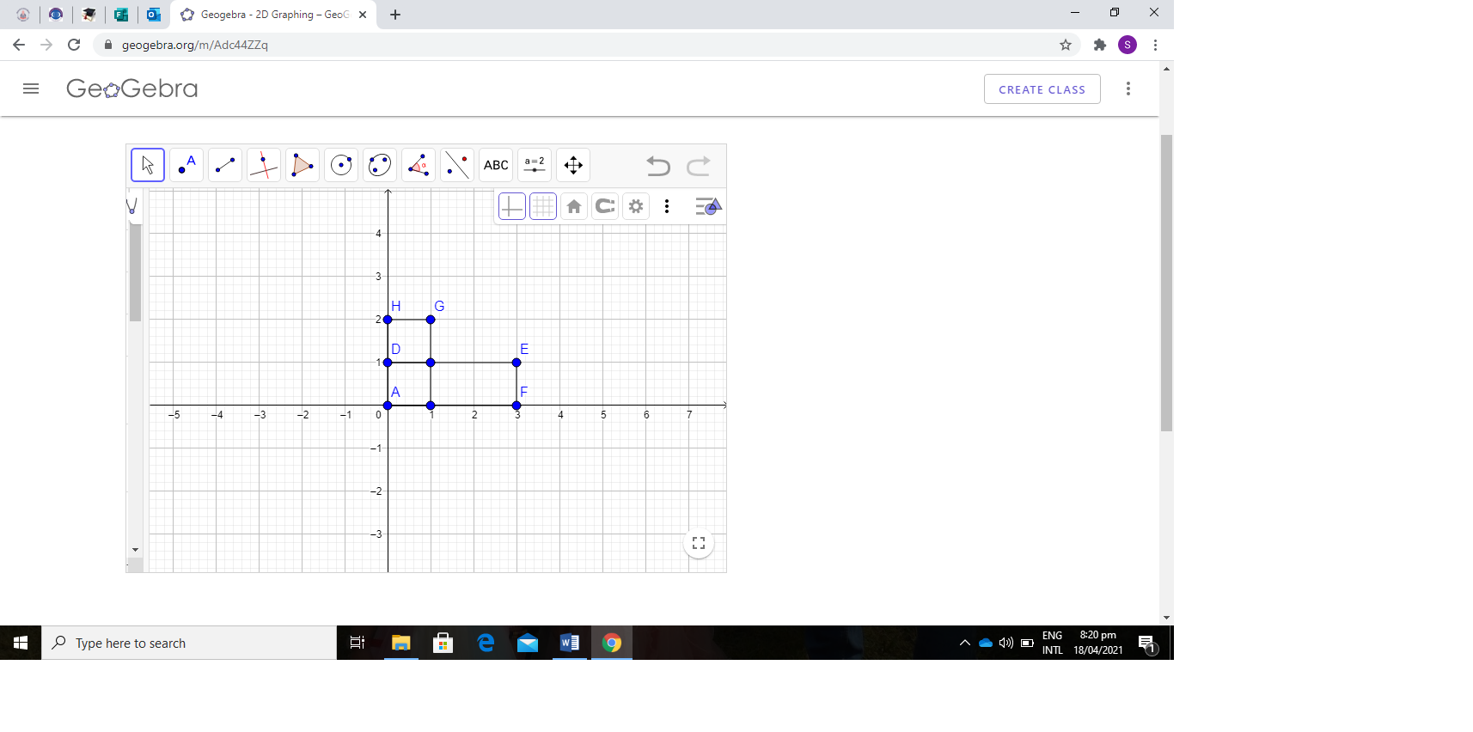

$$T\left[\begin{aligned}0 \\ 0\end{aligned}\right]=\left[\begin{matrix}3 & 0 \\ 0 & 1\end{matrix}\right]\left[\begin{aligned}0 \\ 0\end{aligned}\right]=\left[\begin{aligned}0 \\ 0\end{aligned}\right]$$

$T\left[\begin{aligned}1 \\ 0\end{aligned}\right]=\left[\begin{matrix}3 & 0 \\ 0 & 1\end{matrix}\right]\left[\begin{aligned}1 \\ 0\end{aligned}\right]=\left[\begin{aligned}3 \\ 0\end{aligned}\right]$

$T\left[\begin{aligned}1 \\ 1\end{aligned}\right]=\left[\begin{matrix}3 & 0 \\ 0 & 1\end{matrix}\right]\left[\begin{aligned}1 \\ 1\end{aligned}\right]=\left[\begin{aligned}3 \\ 1\end{aligned}\right]$

$T\left[\begin{aligned}0 \\ 1\end{aligned}\right]=\left[\begin{matrix}3 & 0 \\ 0 & 1\end{matrix}\right]\left[\begin{aligned}0 \\ 1\end{aligned}\right]=\left[\begin{aligned}0 \\ 1\end{aligned}\right]$

**Along y-axis**

As $T\left(\vec{x}\right)=A\vec{x}; ∀\vec{x}∈R^{2}$

$$A=\left[\begin{matrix}1 & 0 \\ 0 & 2\end{matrix}\right]$$

$T\left[\begin{aligned}0 \\ 0\end{aligned}\right]=\left[\begin{matrix}1 & 0 \\ 0 & 2\end{matrix}\right]\left[\begin{aligned}0 \\ 0\end{aligned}\right]=\left[\begin{aligned}0 \\ 0\end{aligned}\right]$

$T\left[\begin{aligned}1 \\ 0\end{aligned}\right]=\left[\begin{matrix}1 & 0 \\ 0 & 2\end{matrix}\right]\left[\begin{aligned}1 \\ 0\end{aligned}\right]=\left[\begin{aligned}1 \\ 0\end{aligned}\right]$

$T\left[\begin{aligned}1 \\ 1\end{aligned}\right]=\left[\begin{matrix}1 & 0 \\ 0 & 2\end{matrix}\right]\left[\begin{aligned}1 \\ 1\end{aligned}\right]=\left[\begin{aligned}1 \\ 2\end{aligned}\right]$

$T\left[\begin{aligned}0 \\ 1\end{aligned}\right]=\left[\begin{matrix}1 & 0 \\ 0 & 2\end{matrix}\right]\left[\begin{aligned}0 \\ 1\end{aligned}\right]=\left[\begin{aligned}0 \\ 2\end{aligned}\right]$

**Example 2: (Stretching of triangle)**

Find the image of a triangle with vertices $A\left(1, 1\right), B\left(4, 1\right), C\left(3, 4\right)$, when it is stretched along

1. X-axis with factor $\frac{3}{2}$.
2. Y-axis with factor $\frac{1}{2}$.

**Solution: (along x-axis)** As $$T\left(\vec{x}\right)=A\vec{x}; ∀\vec{x}∈R^{2}$$

$$A=\left[\begin{matrix}\frac{3}{2} & 0 \\ 0 & 1\end{matrix}\right]$$

$$T\left[\begin{aligned}1 \\ 1\end{aligned}\right]=\left[\begin{matrix}\frac{3}{2} & 0 \\ 0 & 1\end{matrix}\right]\left[\begin{aligned}1 \\ 1\end{aligned}\right]=\left[\begin{aligned}\frac{3}{2} \\ 1\end{aligned}\right]$$

$$T\left[\begin{aligned}4 \\ 1\end{aligned}\right]=\left[\begin{matrix}\frac{3}{2} & 0 \\ 0 & 1\end{matrix}\right]\left[\begin{aligned}4 \\ 1\end{aligned}\right]=\left[\begin{aligned}6 \\ 1\end{aligned}\right]$$

$$T\left[\begin{aligned}3 \\ 4\end{aligned}\right]=\left[\begin{matrix}\frac{3}{2} & 0 \\ 0 & 1\end{matrix}\right]\left[\begin{aligned}3 \\ 4\end{aligned}\right]=\left[\begin{aligned}\frac{9}{2} \\ 4\end{aligned}\right]$$

**Along y-axis:** As $$T\left(\vec{x}\right)=A\vec{x}; ∀\vec{x}∈R^{2}$$

$$A=\left[\begin{matrix}1 & 0 \\ 0 & \frac{3}{2}\end{matrix}\right]$$

$$T\left[\begin{aligned}1 \\ 1\end{aligned}\right]=\left[\begin{matrix}1 & 0 \\ 0 & \frac{3}{2}\end{matrix}\right]\left[\begin{aligned}1 \\ 1\end{aligned}\right]=\left[\begin{aligned}1 \\ \frac{3}{2}\end{aligned}\right]$$

$$T\left[\begin{aligned}4 \\ 1\end{aligned}\right]=\left[\begin{matrix}1 & 0 \\ 0 & \frac{3}{2}\end{matrix}\right]\left[\begin{aligned}4 \\ 1\end{aligned}\right]=\left[\begin{aligned}4 \\ \frac{3}{2}\end{aligned}\right]$$

$$T\left[\begin{aligned}3 \\ 4\end{aligned}\right]=\left[\begin{matrix}1 & 0 \\ 0 & \frac{3}{2}\end{matrix}\right]\left[\begin{aligned}3 \\ 4\end{aligned}\right]=\left[\begin{aligned}3 \\ 6\end{aligned}\right]$$

**Example 3: (Stretching of Circle)**

Let ${(x-2)}^{2}+{(y-1)}^{2}=4$ be a circle. Find its equation and image under stretching along x-axis by factor 2.

**Solution:** As $$T\left(\vec{x}\right)=A\vec{x}; ∀\vec{x}∈R^{2}$$

$$T\left[\begin{aligned}x \\ y\end{aligned}\right]=\left[\begin{matrix}2 & 0 \\ 0 & 1\end{matrix}\right]\left[\begin{aligned}x \\ y\end{aligned}\right]$$

$$\left[\begin{aligned}x^{'} \\ y^{'}\end{aligned}\right]=\left[\begin{aligned}2x \\ y\end{aligned}\right]$$

$\left\{\begin{aligned}x^{'}=2x \\ y^{'}=y\end{aligned}\right.$ $⟹\left\{\begin{aligned}x=\frac{x^{'}}{2} \\ y=y'\end{aligned}\right.$

Put value of $x$ and $y$ in original equation of circle and get

$$\frac{{\left(x^{'}-4\right)}^{2}}{16}+\frac{{\left(y^{'}-1\right)}^{2}}{4}=1$$

It represents the ellipse.

**Practice Problems**

Q1. Let ${(x-2)}^{2}+{(y-1)}^{2}=4$ be a circle. Find its equation and image under stretching along Y-axis by factor $\frac{3}{2}$.

Q2. Find the stretching of an ellipse $\frac{{\left(x-4\right)}^{2}}{16}+\frac{{\left(y-1\right)}^{2}}{4}=1$ along x-axis by factor 2.

Q3. Find the image of a triangle with vertices $A\left(1, 1\right), B\left(4, 2\right), C\left(2, 3\right)$, when it is stretched along

1. X-axis with factor 3
2. Y-axis with factor $1$.

**3- Shearing**

Shearing of a point along x-axis by factor k can be defined as:

The movement of point parallel to x-axis keeping the distance of the point from the x-axis. i.e. the movement of point parallel to x-axis depending upon the y-component of the point.

* Shearing at a point along x-axis by factor k in the matrix form can be represented as

$$T\left(\vec{x}\right)=A\vec{x}; ∀\vec{x}∈R^{2}$$

Where

$$A=\left[\begin{matrix}1 & k \\ 0 & 1\end{matrix}\right]$$

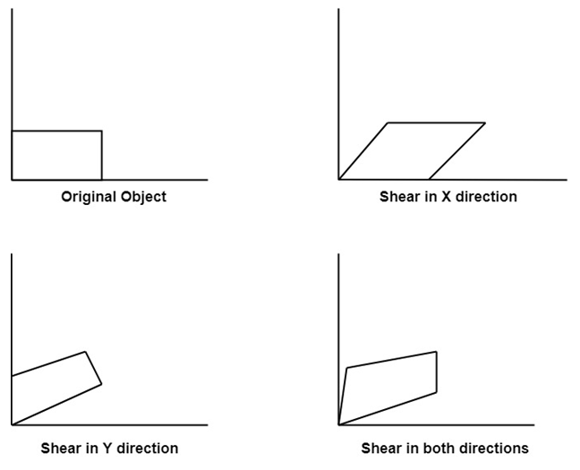

**Example 1: (Shearing of vector)**

Shear a point $A=(5,3)$ along x-axis by the factor 2.

**Solution:** As $$T\left(\vec{x}\right)=A\vec{x}; ∀\vec{x}∈R^{2}$$

$$T\left[\begin{aligned}x \\ y\end{aligned}\right]=\left[\begin{matrix}1 & k \\ 0 & 1\end{matrix}\right]\left[\begin{aligned}x \\ y\end{aligned}\right]=\left[\begin{aligned}x+ky \\ y\end{aligned}\right]$$

$$T\left[\begin{aligned}5 \\ 3\end{aligned}\right]=\left[\begin{matrix}1 & 2 \\ 0 & 1\end{matrix}\right]\left[\begin{aligned}5 \\ 3\end{aligned}\right]=\left[\begin{aligned}11 \\ 3\end{aligned}\right]$$

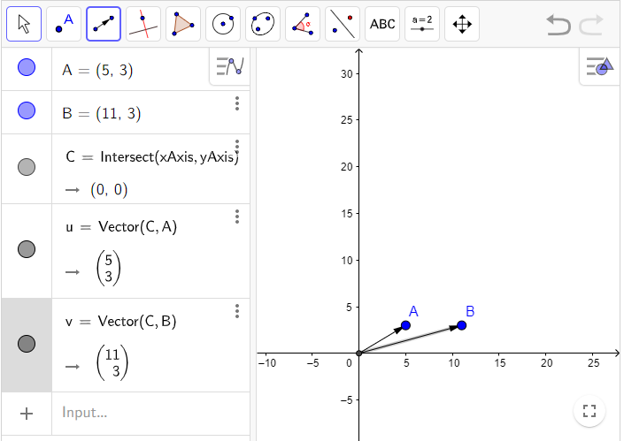

**Note:**

1. A transformation that slants the shape of an object is called the shear transformation.
2. Shearing of an object along y-axis by factor k in matrix form can be expressed as:

$$T\left(\vec{x}\right)=A\vec{x}; ∀x∈R^{2}$$

Where

$$A=\left[\begin{matrix}1 & 0 \\ k & 1\end{matrix}\right]$$

**Example 2: (Shearing of Triangle)**

A triangle with vertices $\left(0, 0\right), \left(4,2\right), \left(1, 6\right)$. Find the image of triangle when it will be shear along y axis by factor 2.

**Solution:** As $T\left(\vec{x}\right)=A\vec{x}; ∀\vec{x}∈R^{2}$

$$T\left[\begin{aligned}0 \\ 0\end{aligned}\right]=\left[\begin{matrix}1 & 0 \\ 2 & 1\end{matrix}\right]\left[\begin{aligned}0 \\ 0\end{aligned}\right]=\left[\begin{aligned}0 \\ 0\end{aligned}\right]$$

$$T\left[\begin{aligned}4 \\ 2\end{aligned}\right]=\left[\begin{matrix}1 & 0 \\ 2 & 1\end{matrix}\right]\left[\begin{aligned}4 \\ 2\end{aligned}\right]=\left[\begin{aligned}4 \\ 10\end{aligned}\right]$$

$$T\left[\begin{aligned}1 \\ 6\end{aligned}\right]=\left[\begin{matrix}1 & 0 \\ 2 & 1\end{matrix}\right]\left[\begin{aligned}1 \\ 6\end{aligned}\right]=\left[\begin{aligned}1 \\ 8\end{aligned}\right]$$

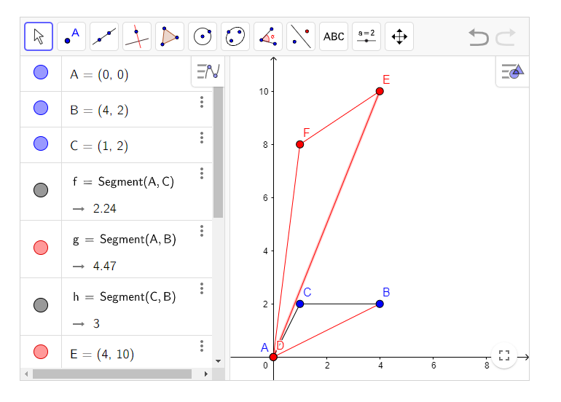

**Example 3: (Shearing of Rectangle)**

Consider the rectangle with vertices $\left(0, 0\right), \left(0,2\right), \left(4, 0\right), (4,2)$. Shear this rectangle along x-axis by factor 2.

**Example 4: (Shearing of Rectangle)**

Consider the rectangle with vertices $\left(0, 0\right), \left(0,2\right), \left(4, 0\right), (4,2)$. Shear this rectangle along y-axis by factor -3.

**Example 5:**

In each part describe the matrix operator corresponding to A and show it effect on unit square

$\left[\begin{matrix}1 & 2 \\ 0 & 1\end{matrix}\right], b)\left[\begin{matrix}2 & 0 \\ 0 & 2\end{matrix}\right], c) \left[\begin{matrix}2 & 0 \\ 0 & 1\end{matrix}\right]$

**Example 6:** Let $x^{2}+y^{2}=4$ be a circle. Find its equation and image under the effect of shear parallel to x-axis by factor -2.

**Solution:** As $$T\left(\vec{x}\right)=A\vec{x}; ∀\vec{x}∈R^{2}$$

$$T\left[\begin{aligned}x \\ y\end{aligned}\right]=\left[\begin{matrix}1 & -2 \\ 0 & 1\end{matrix}\right]\left[\begin{aligned}x \\ y\end{aligned}\right]$$

$$\left[\begin{aligned}x^{'} \\ y^{'}\end{aligned}\right]=\left[\begin{aligned}x-2y \\ y\end{aligned}\right]$$

$\left\{\begin{aligned}x^{'}=x-2y \\ y^{'}=y\end{aligned}\right.$ $⇒\left\{\begin{aligned}x=x^{'}+2y' \\ y=y'\end{aligned}\right.$

Put value of $x$ and $y$ in original equation of circle: $x^{2}+y^{2}=4$

equation of circle:

$$x^{2}+y^{2}=4$$

$${\left(x^{'}+2y^{'}\right)}^{2}+y^{'2}=4$$

$$x^{'2}+4y^{'2}+4x^{'}y^{'}+y^{'2}=4$$

$$x^{'2}+5y^{'2}+4x^{'}y^{'}=4$$

$$x^{'2}+5y^{'2}+4x^{'}y^{'}-4=0$$

For plotting we can neglect the dash (‘) from our sheared equation of circle.

$$x^{2}+5y^{2}+4xy-4=0$$

**General equation of Conics:**

$$Ax^{2}+Bxy+cy^{2}+Dx+Ey+F=0$$

On Comparing, we get:

$$A=1, B=4, C=5$$

$$B^{2}-4AC=4^{2}-4\left(1\right)\left(5\right)=16-20=-4<0$$

So we get ellipse.

**Remarks: General equation of Conics:**

$Ax^{2}+Bxy+cy^{2}+Dx+Ey+F=0$

1. If $B^{2}-4AC<0, we get ellipse.$
2. If $B^{2}-4AC>0, we get hyperbola.$
3. If $B^{2}-4AC=0, we get parabola.$

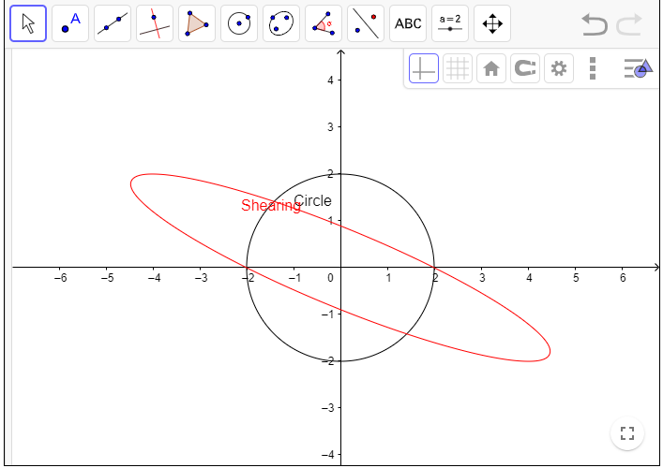

**Example 6:** Let ${(x+2)}^{2}+({y+1)}^{2}=4$ be a circle. Find its equation and image under the effect of shear parallel to y-axis by factor $\frac{3}{2}$.

**Solution:**As $$T\left(\vec{x}\right)=A\vec{x}; ∀\vec{x}∈R^{2}$$

$$T\left[\begin{aligned}x \\ y\end{aligned}\right]=\left[\begin{matrix}1 & 0 \\ \frac{3}{2} & 1\end{matrix}\right]\left[\begin{aligned}x \\ y\end{aligned}\right]$$

$$\left[\begin{aligned}x^{'} \\ y^{'}\end{aligned}\right]=\left[\begin{aligned}x \\ \frac{3}{2}x+y\end{aligned}\right]$$

$\left\{\begin{aligned}x^{'}=x \\ y^{'}=\frac{3}{2}x+y\end{aligned}\right.$ $⇒\left\{\begin{aligned}x=x^{'} \\ y=y^{'}-\frac{3}{2}x'\end{aligned}\right.$

Put value of $x$ and $y$ in original equation of circle:

$${(x+2)}^{2}+({y+1)}^{2}=4$$

$$\frac{13}{4}x^{2}+y^{2}-3xy-3x+2y+1=0$$

On Comparing with General equation of Conics, we get:

$$A=\frac{13}{4}, B=-3, C=1$$

$$B^{2}-4AC={\left(-3\right)}^{2}-4\left(\frac{13}{4}\right)\left(1\right)=9-13=-4<0$$

So we get ellipse.

**Work to do:**

**Q1.**  Let ${(x-2)}^{2}+({y-1)}^{2}=4$ be a circle. Find its equation and image under the effect of shear parallel to x-axis by factor $2$.

**Q2**. Find the vertices of unit square after shearing it along y-axis by a factor 2 and then translating the sheared square by the vector (2, 1).